Install azure-cli in WSL
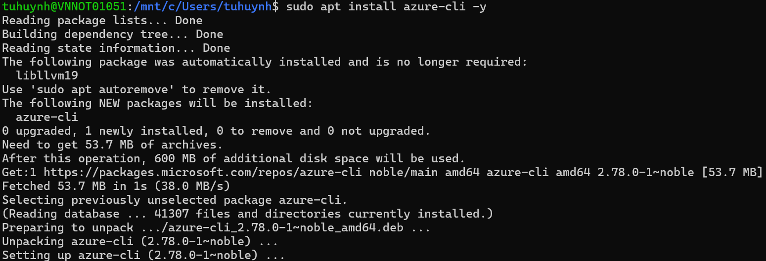

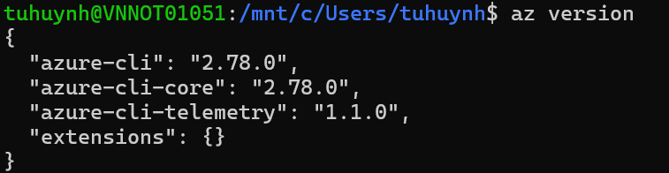
Install terraform
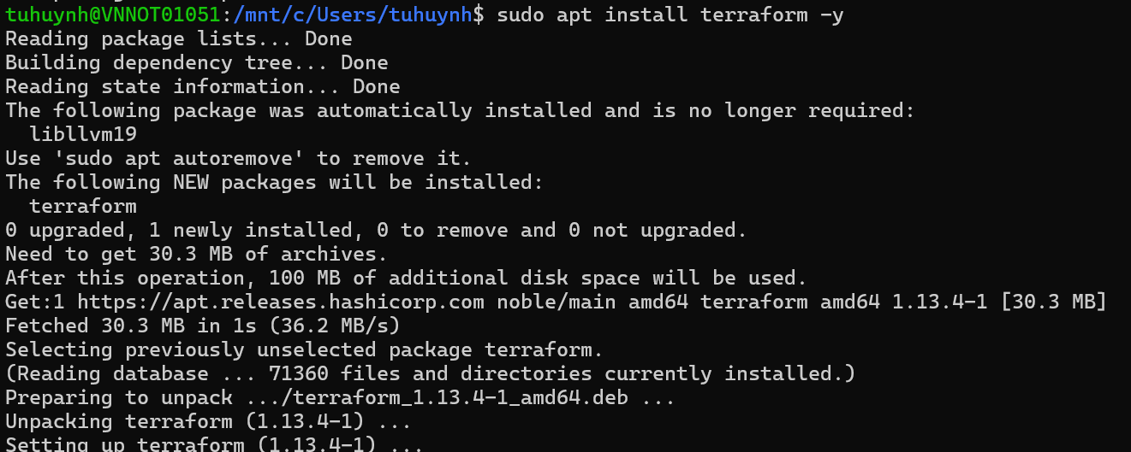
Verify terraform version
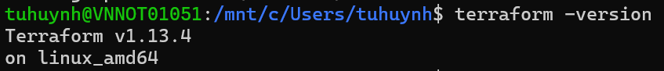
Login to azure
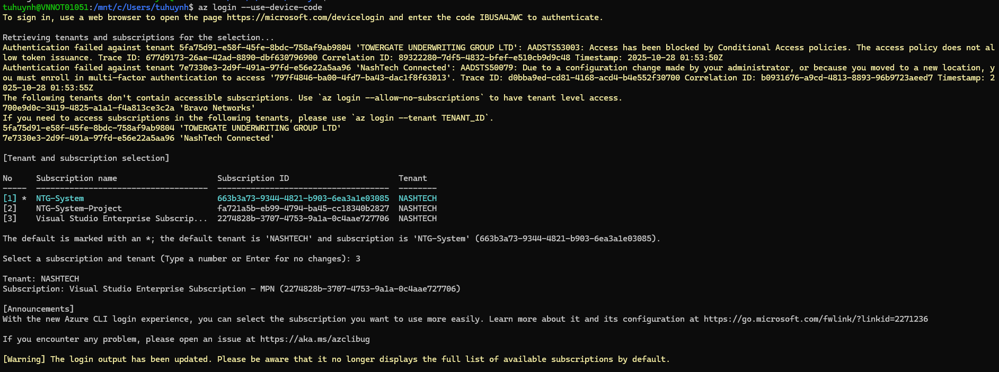
A subscription was created in Portal
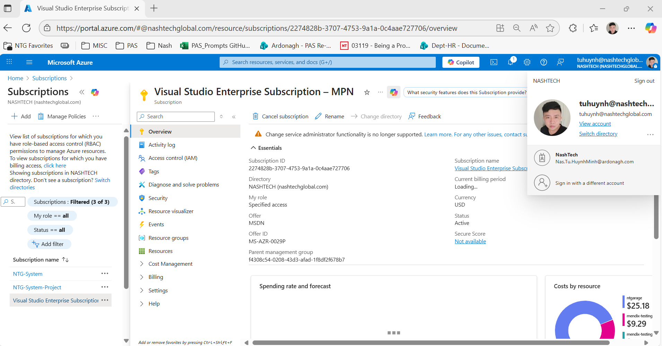
Install all modules required by terraform
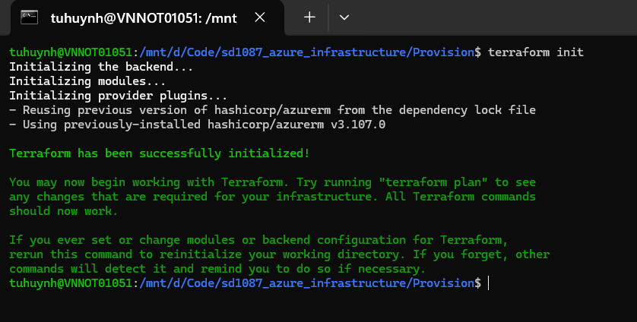
View terraform plan
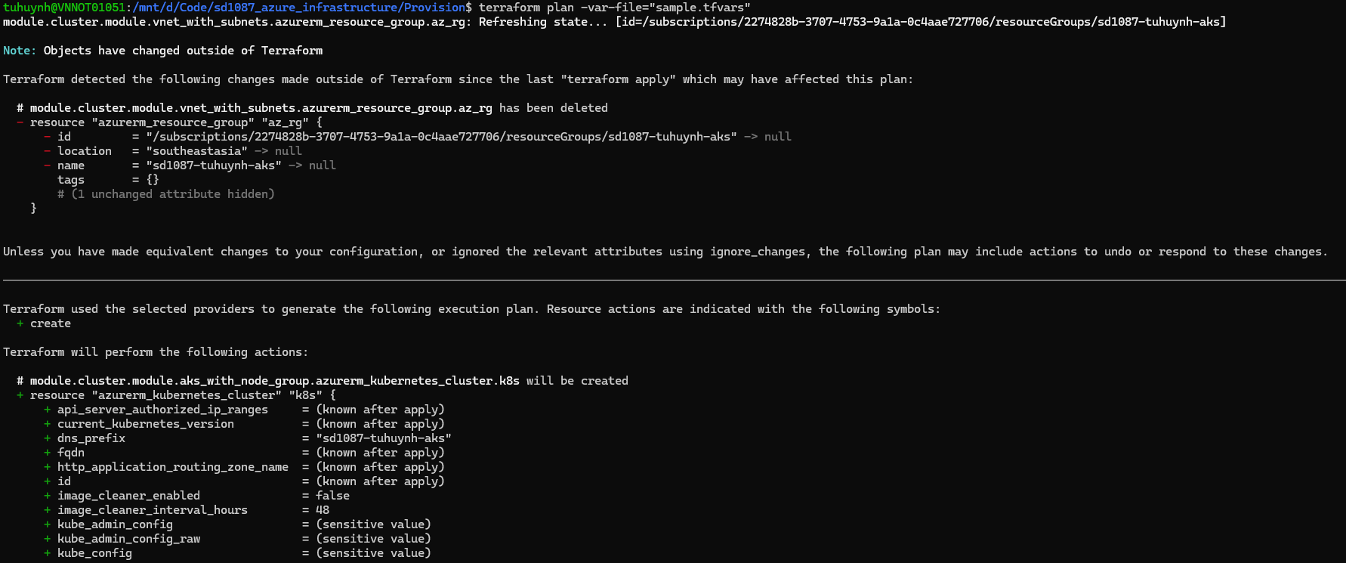
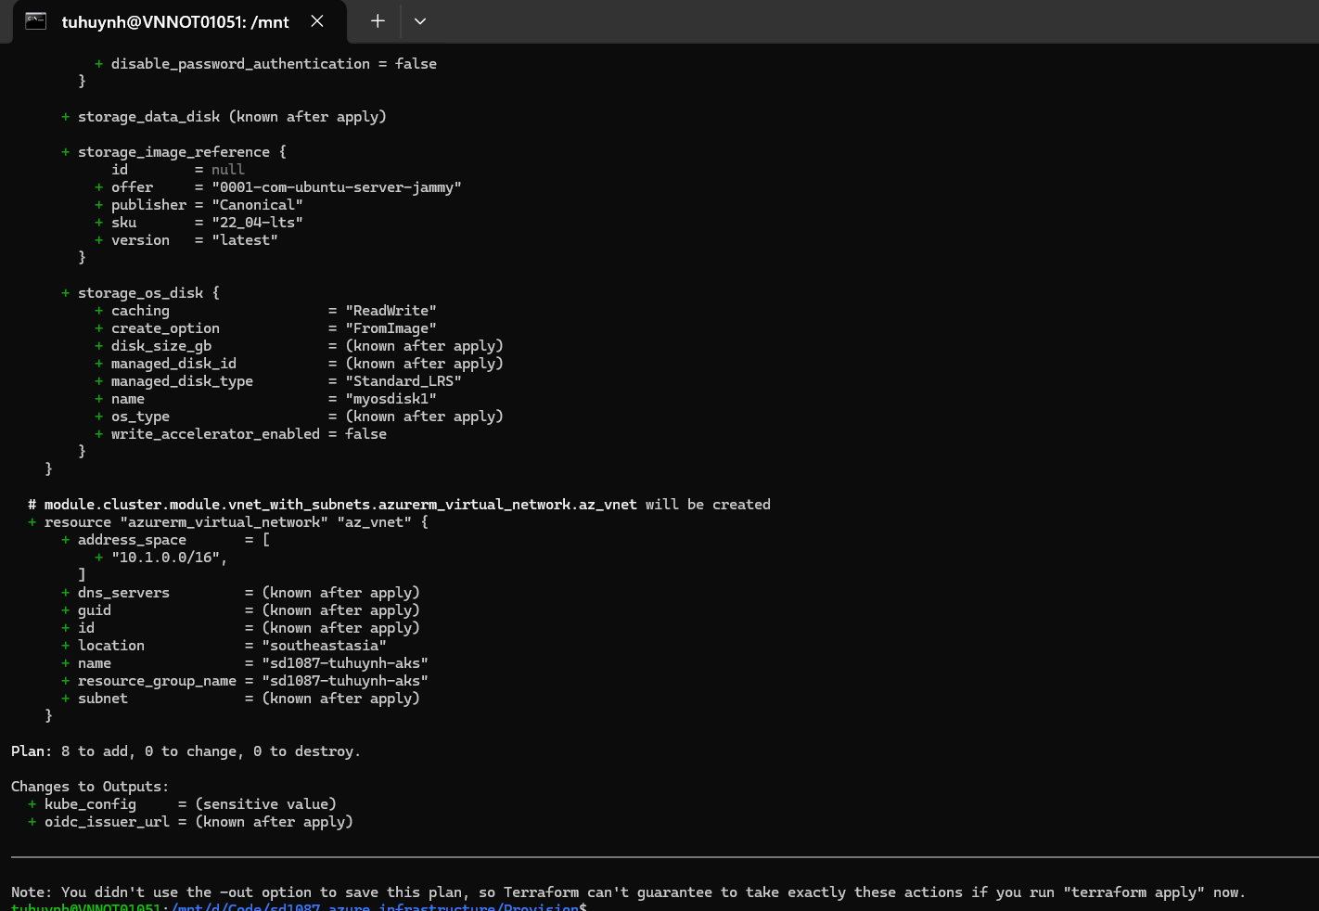

Apply terraform plan to AKS
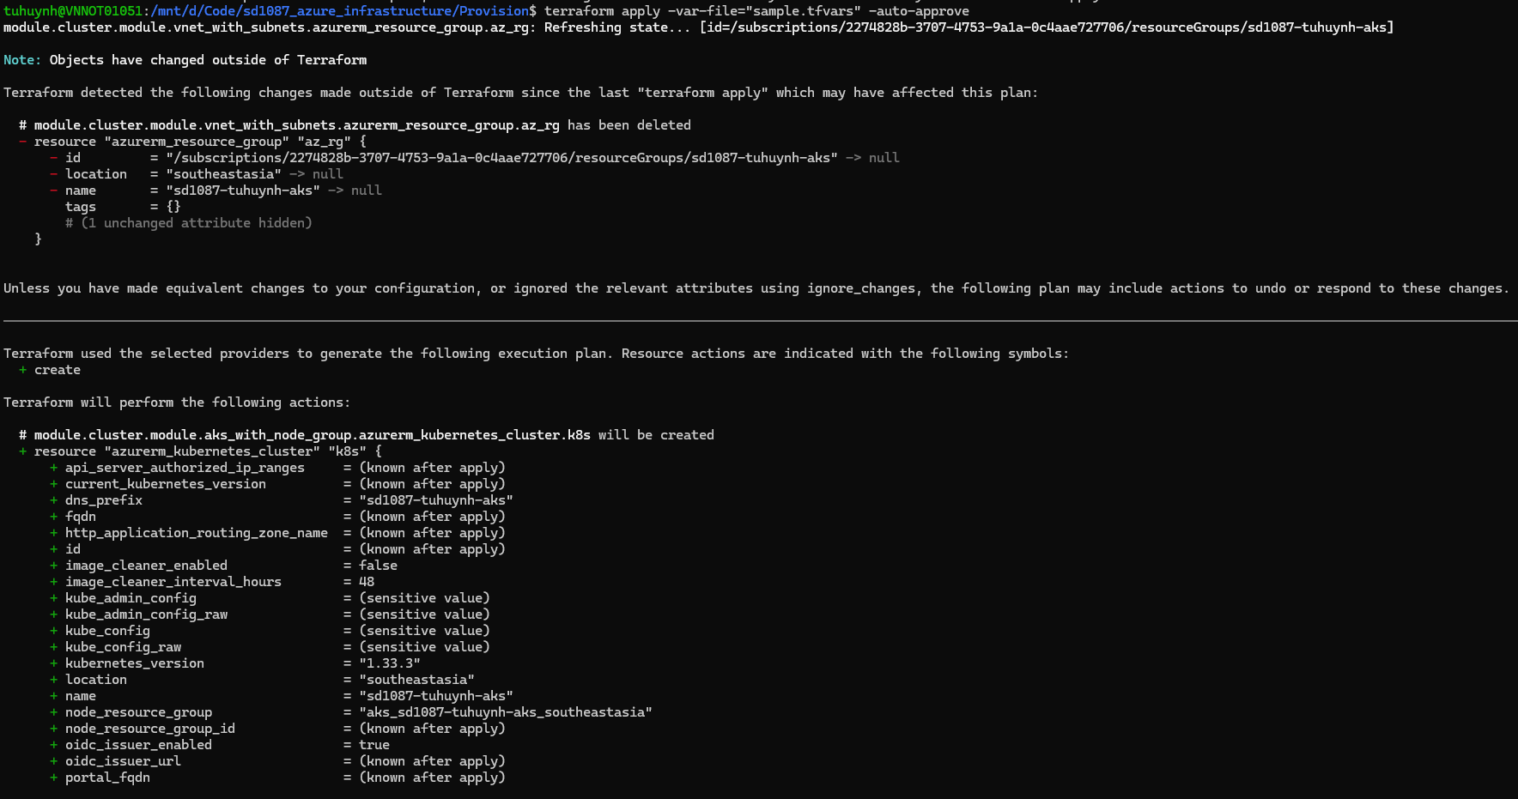

Applied OK
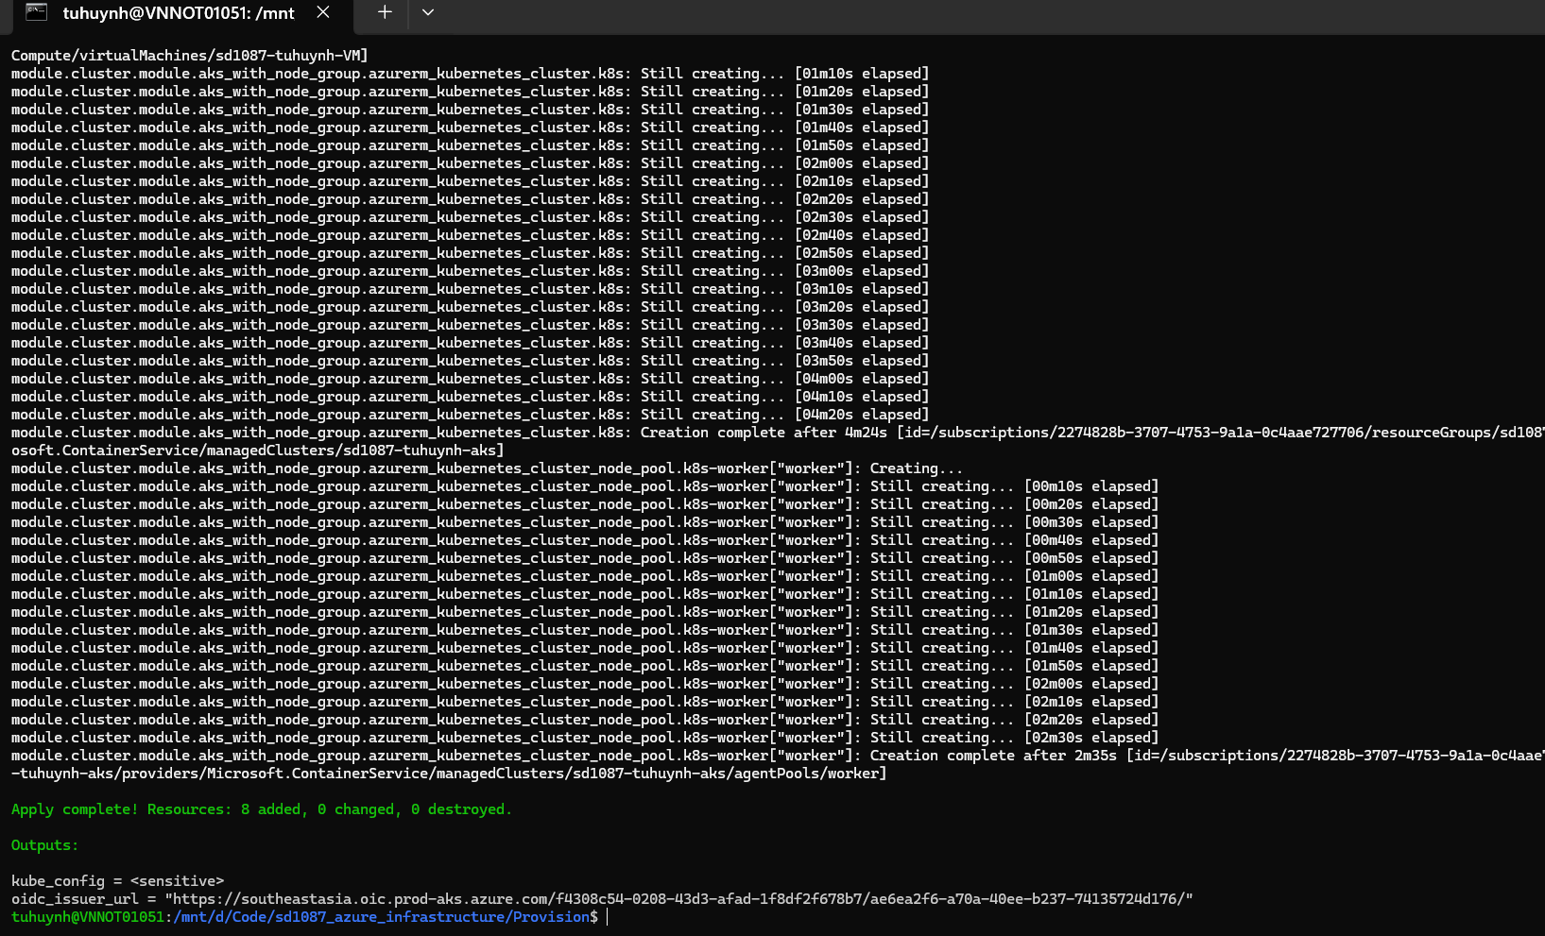
Verify in Azure portal
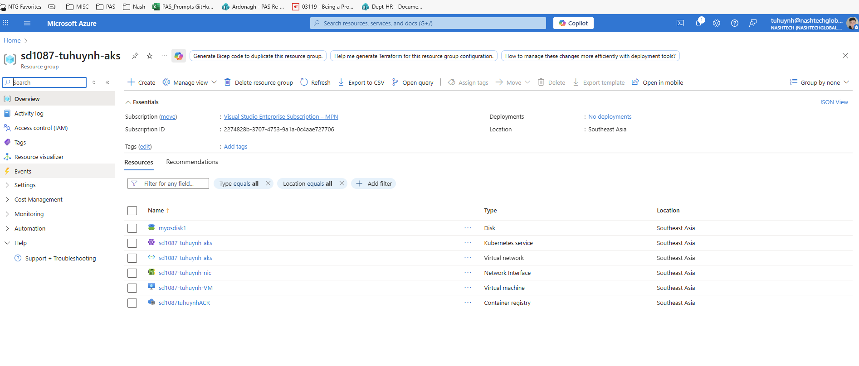
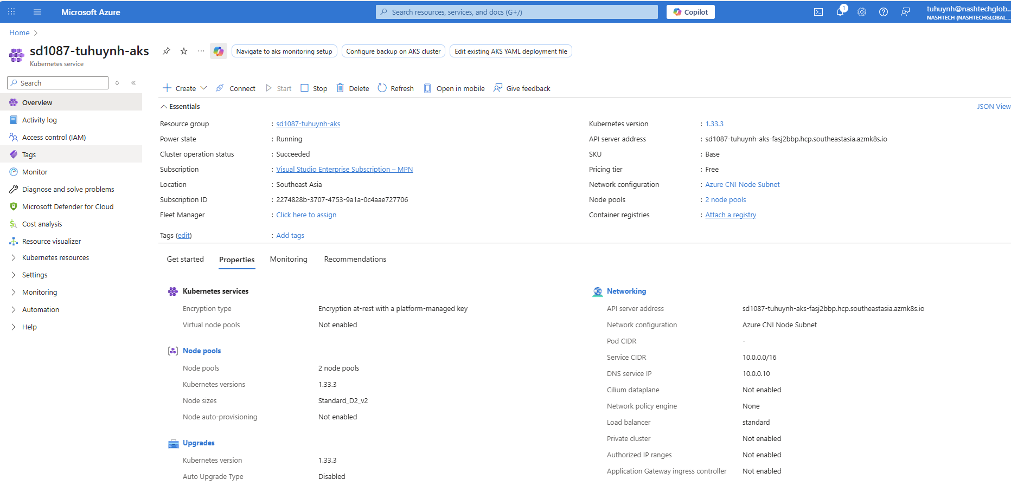
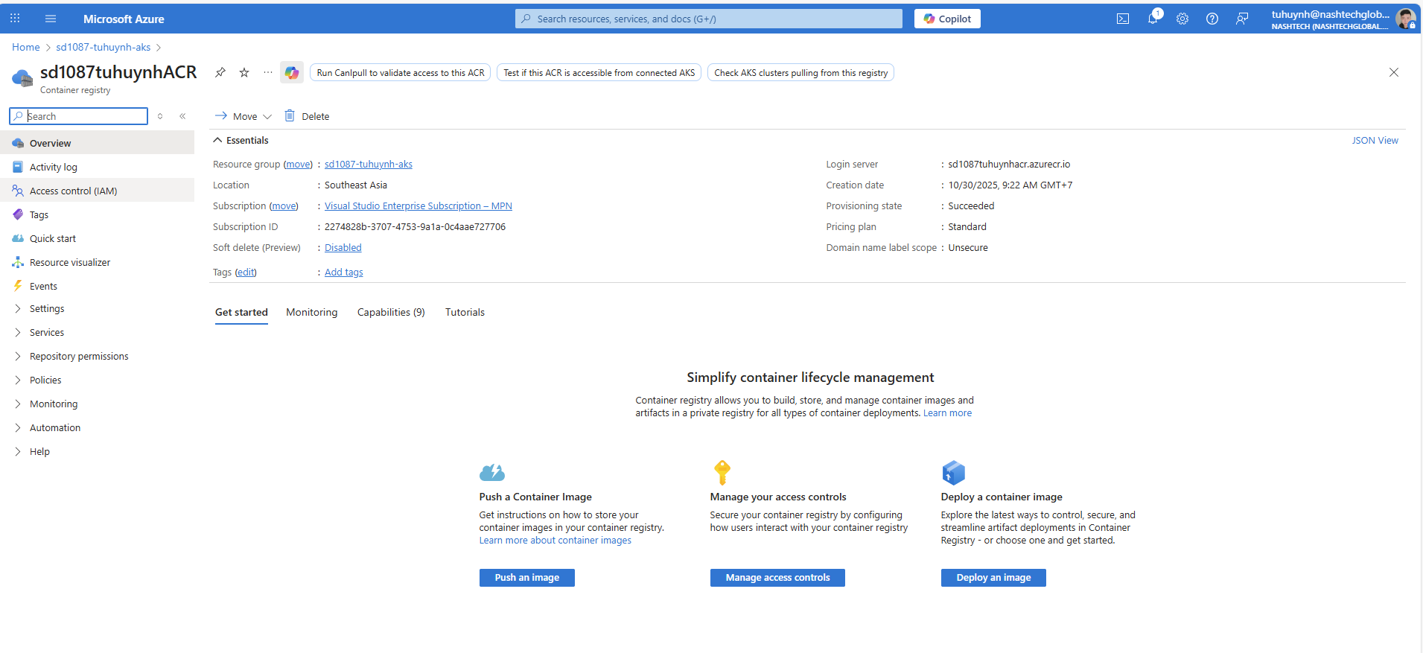

- Run command to connect to AKS
az aks get-credentials --resource-group sd1087-tuhuynh-aks --name sd1087-tuhuynh-aks --admin
kubectl get nodes

Create CI pipeline on Azure Devops
Create new Devops Project
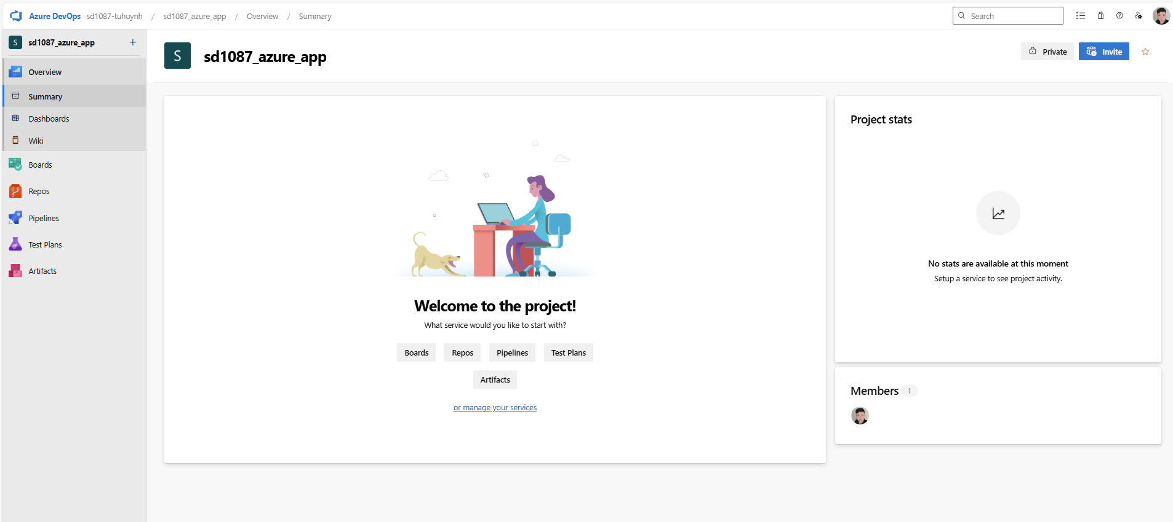

- Click Repo tab in left section -> Import a repository

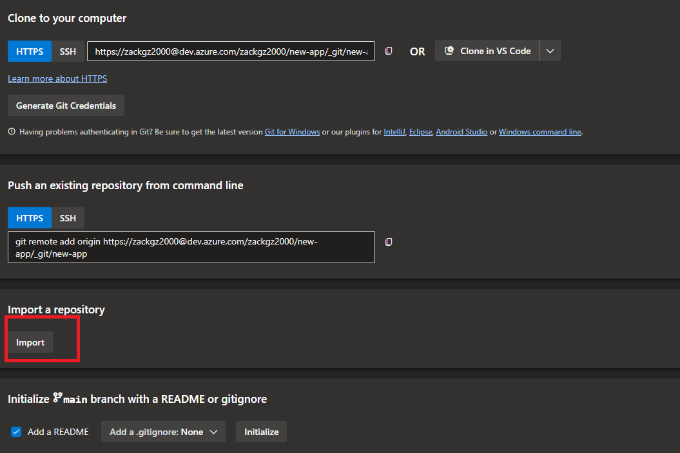

- Fill git url: https://github.com/ngocdung12112000/sd5804-msa.git -> Import
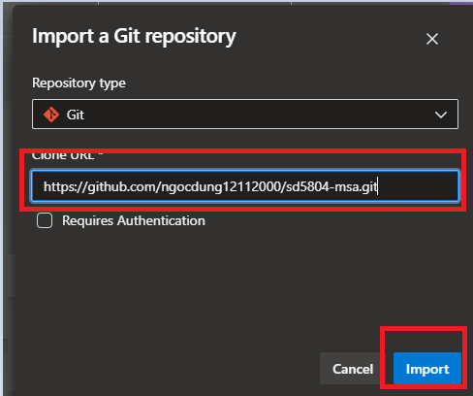
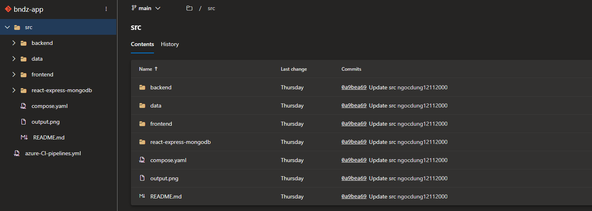

- Go to Project Settings -> Service Connection -> New service connection
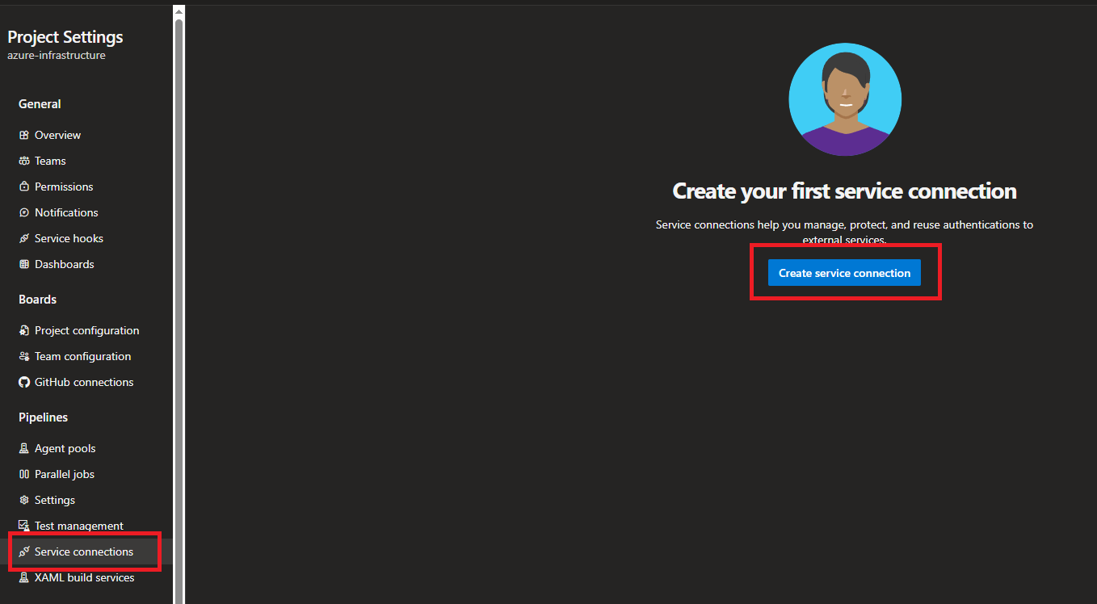

- Select Docker Registry
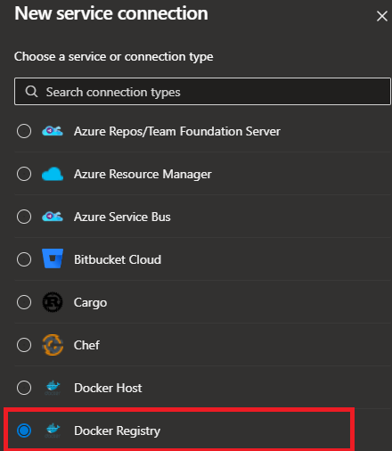

- Check Azure Container Registry
- Choose Azure Container Registry (BNDZACR)
- Add Service Connection Name
- Click Save
This is connection will be used for CI pipeline
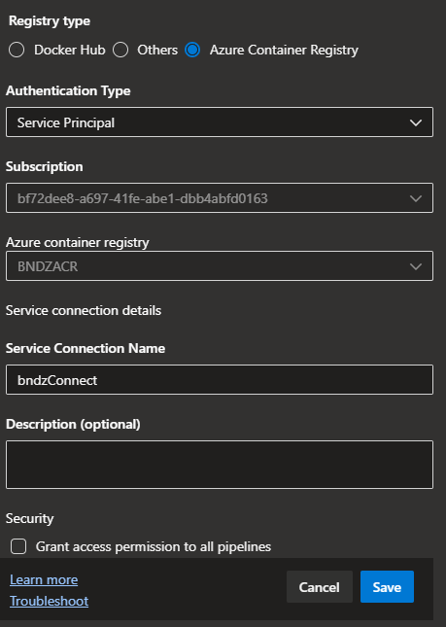

- In left section -> Click Pipeline -> New Pipeline
- Choose Azure Repos git
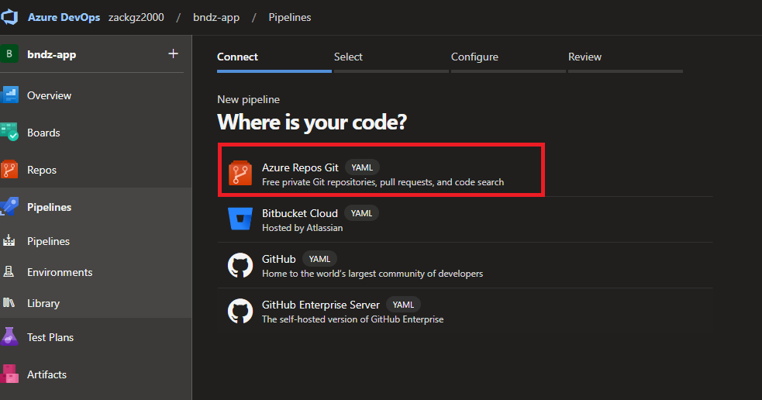

- Select repository
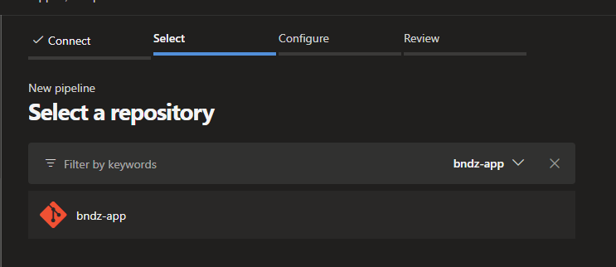

- Select Starter Pipeline
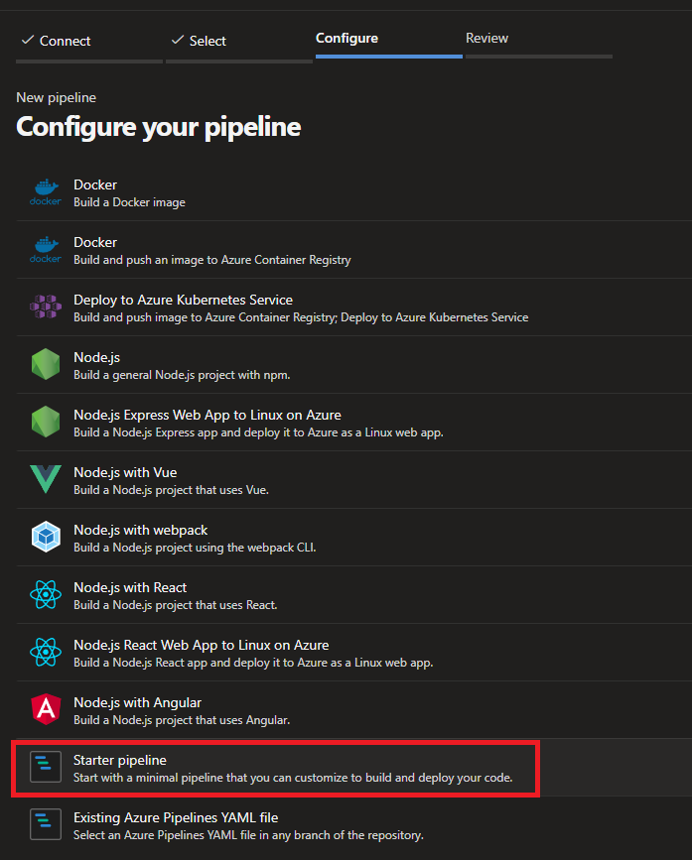

- Add pipeline script and name as azure-pipeline.yml
- Click Save and Run
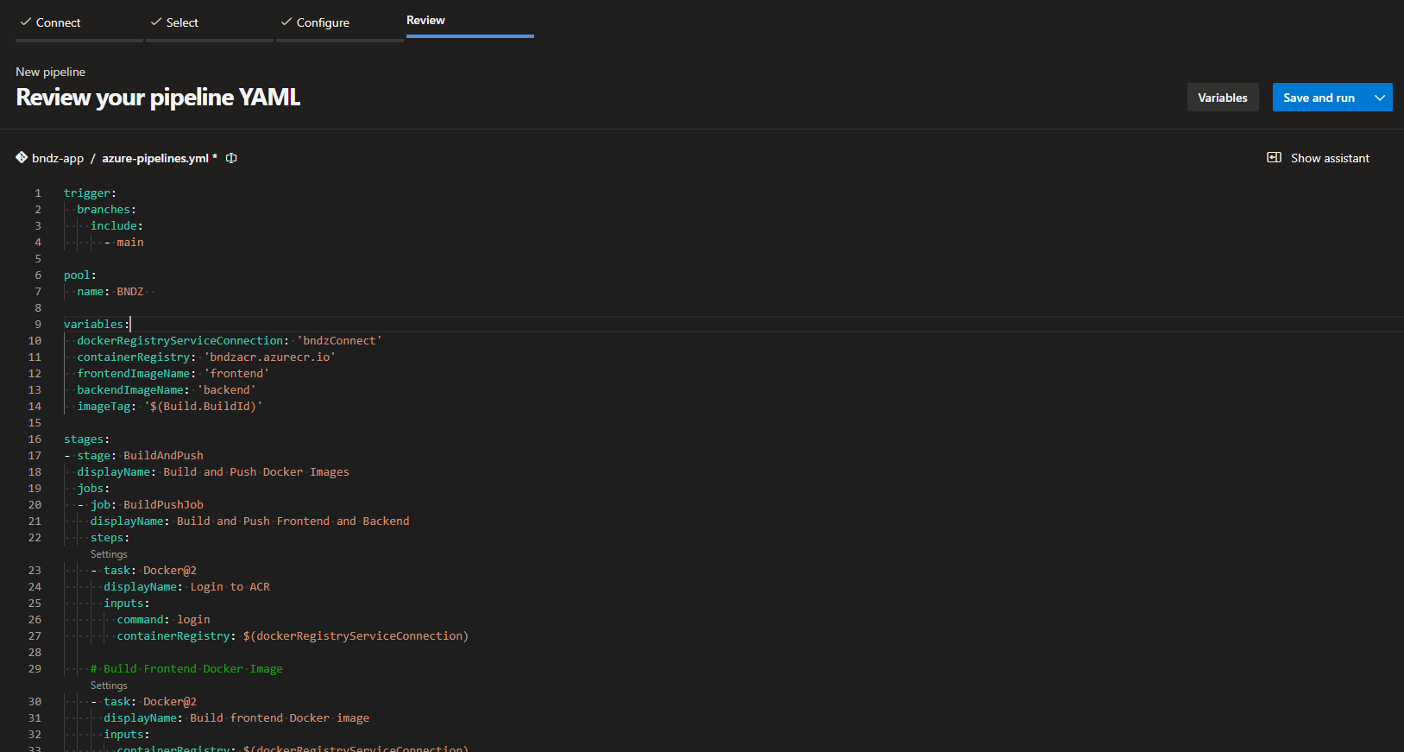

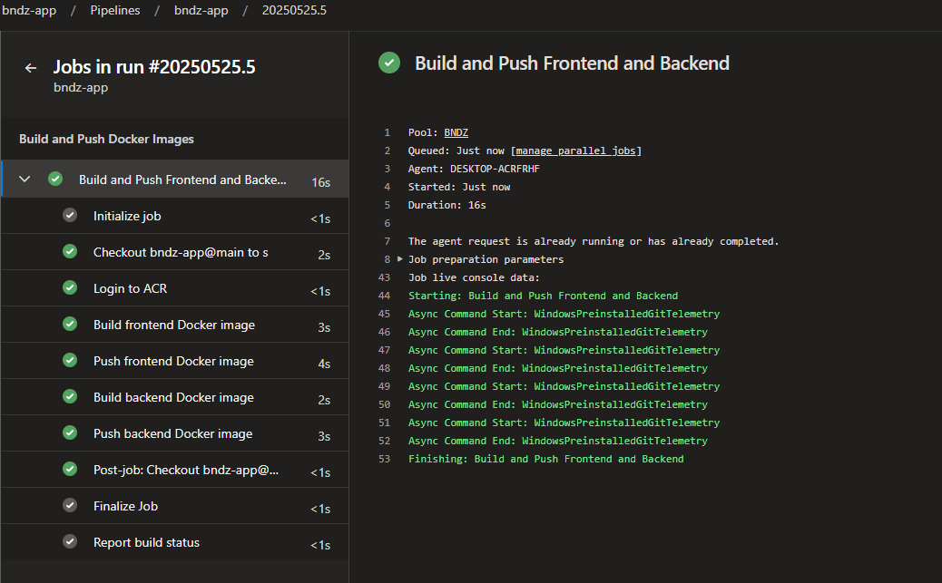

- After pipeline run success
- Go to Container Registry (BNDZACR)
- Click Repositories -> will see 2 images backend and frontend

7. Create CD pipeline on Azure Devops

- Create a project named azure infrastructure
- Import repo https://github.com/ngocdung12112000/sd5804_azure_infrastructure.git

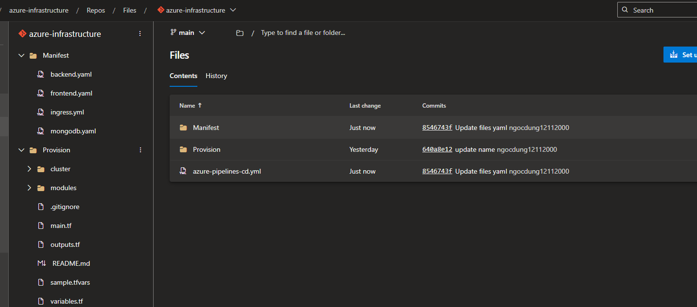

- Go to Project Settings -> Service Connection -> New service connection
- Select Kubernetes
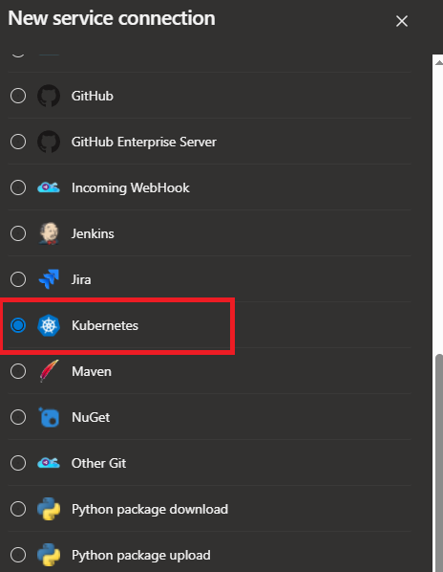

- Choose Azure Subscription
- Select Cluster -> Add Service Connection Name -> Save

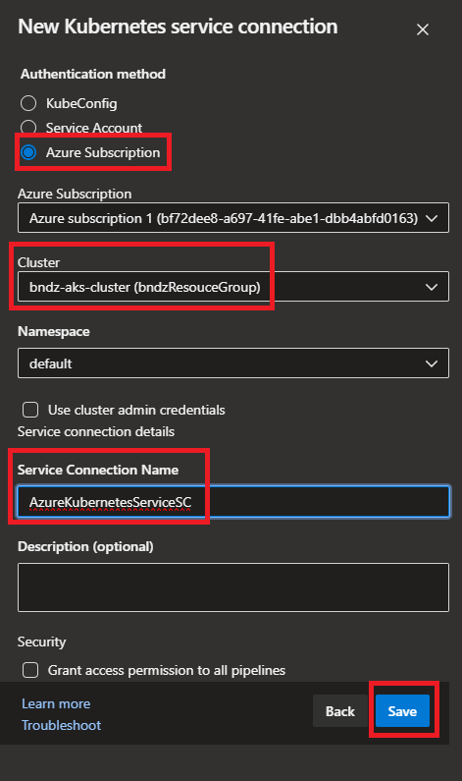
- In left section -> Click Pipeline -> New Pipeline
- Choose Azure Repos git


- Select repository
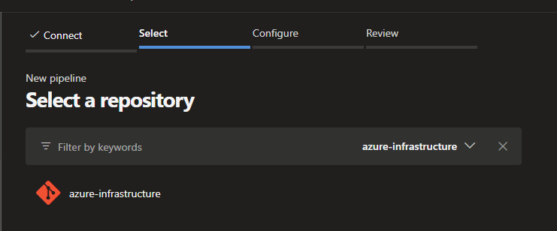

- Select Starter Pipeline
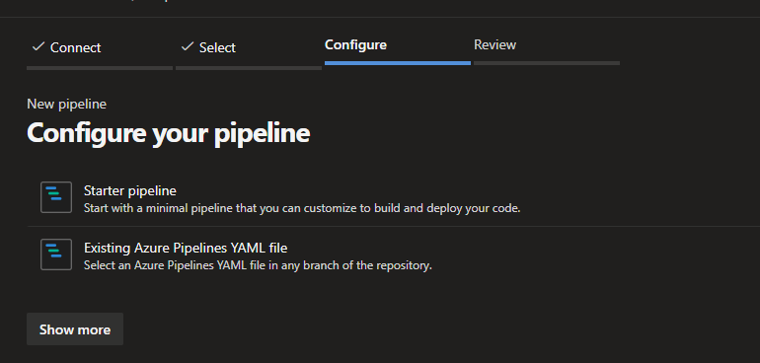

- Update pipeline script azure-pipeline.yml
- Click Save and Run
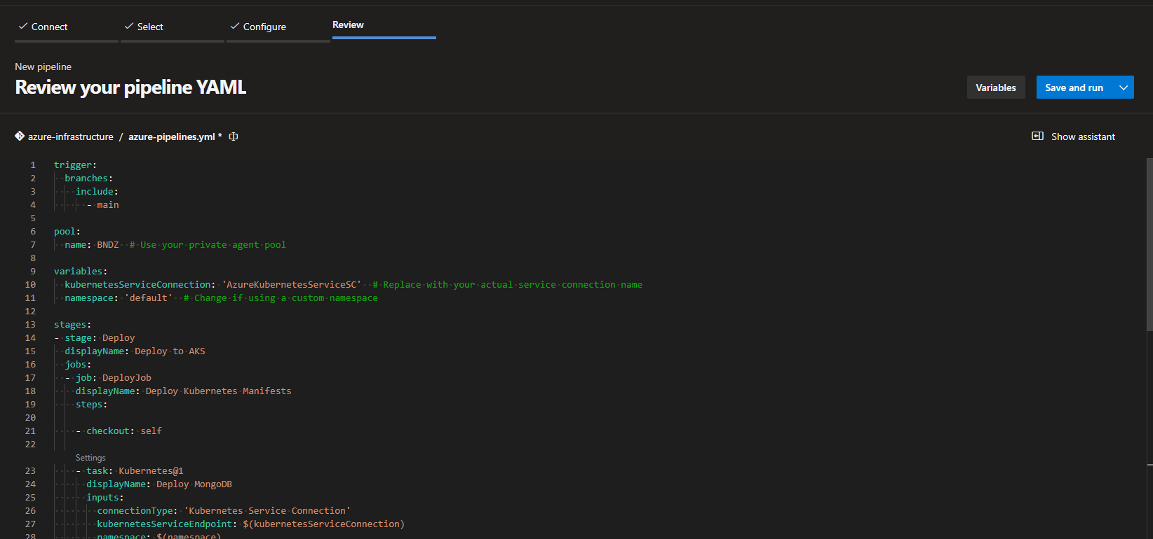

- After Pipeline run success
- Run command
kubectl get nodes

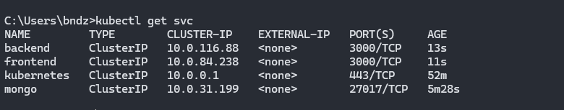

- Run kubectl port-forward service/frontend 3000:3000
